TERRAFORM -06
Watch the Terraform-06 video.
Execute the script shown in the video.
Provision EC2, S3, and VPC using Terraform modules.
Creating ec2 with the different modules
Create an new directory in the directory as development add main.tf file and add code as module so that it will take the module form the main file and add source to that to take the resources from there.
`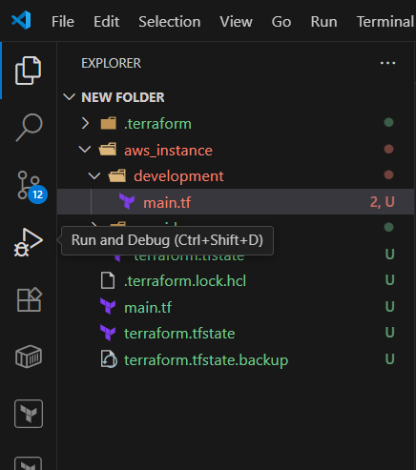
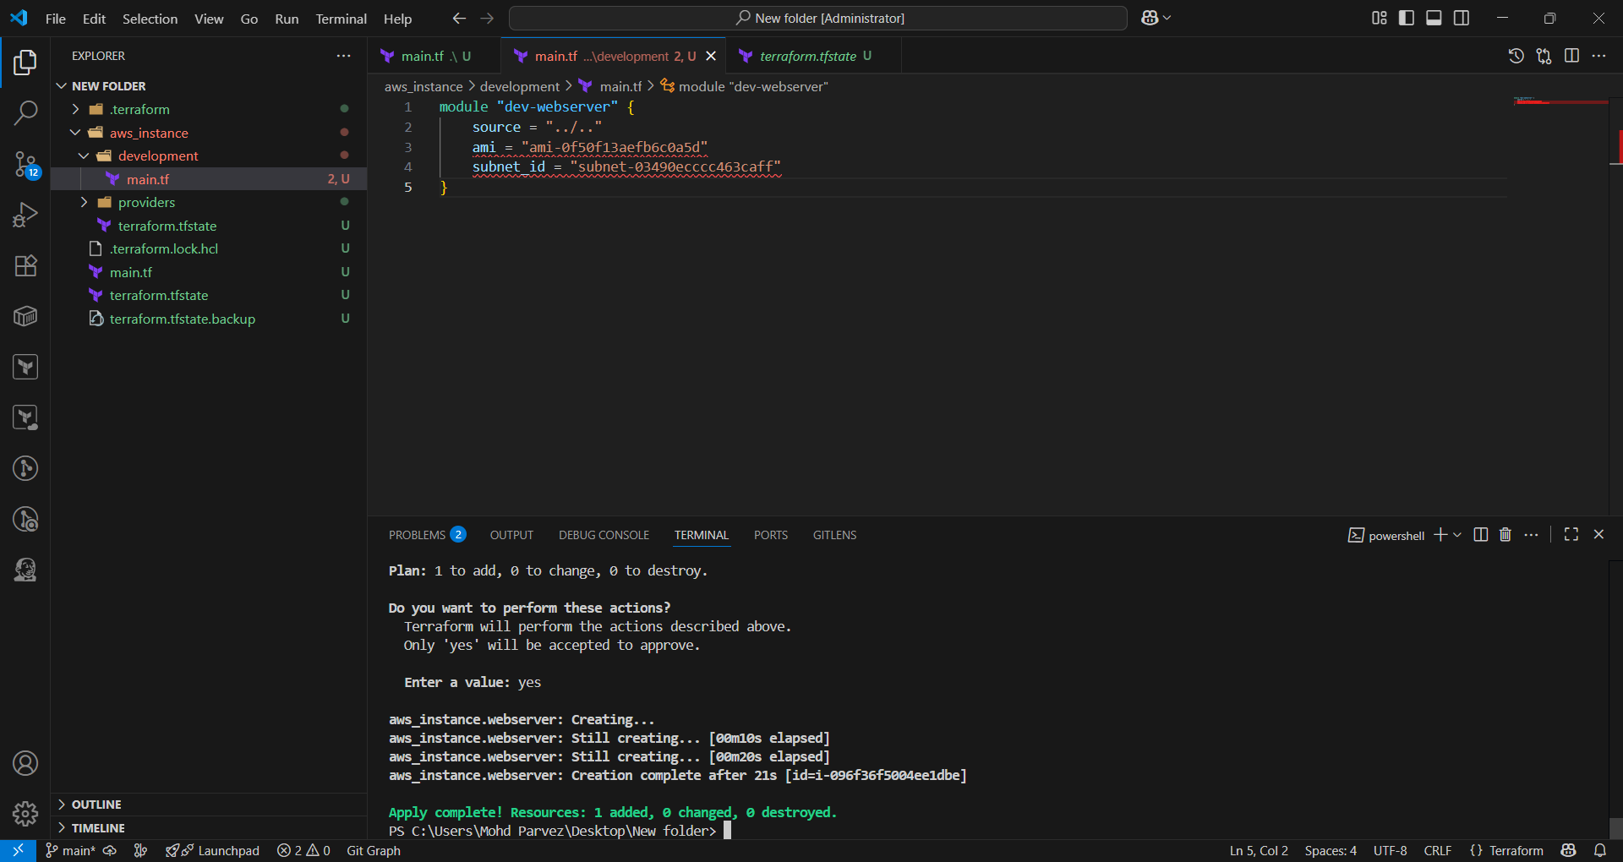
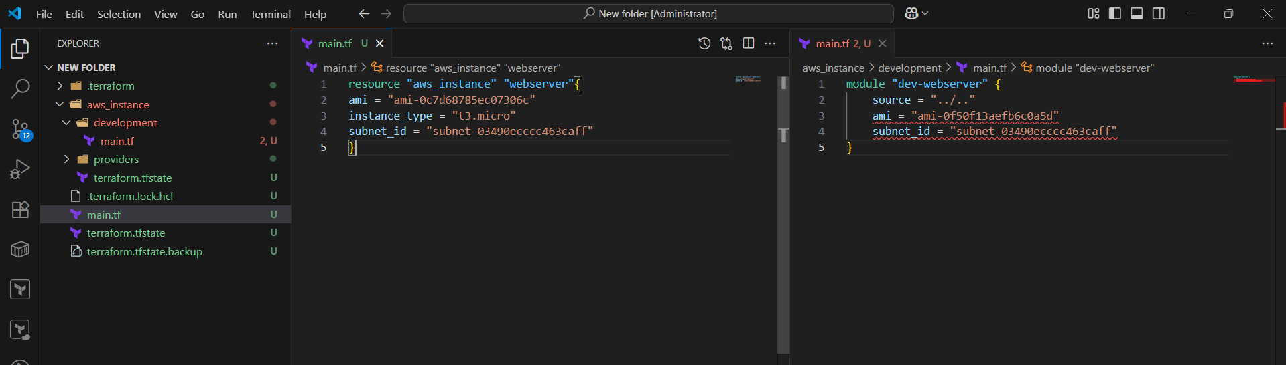
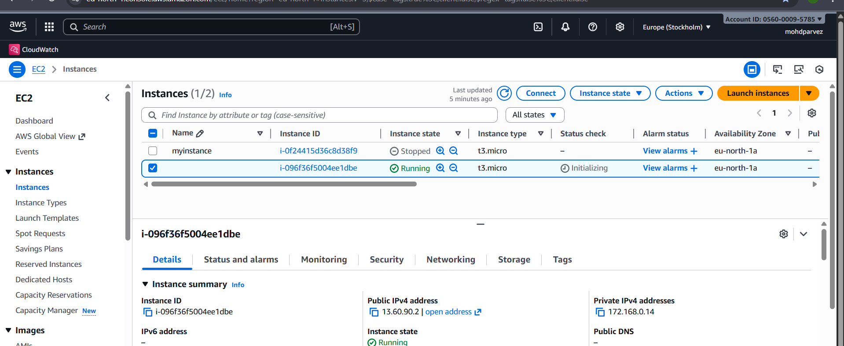
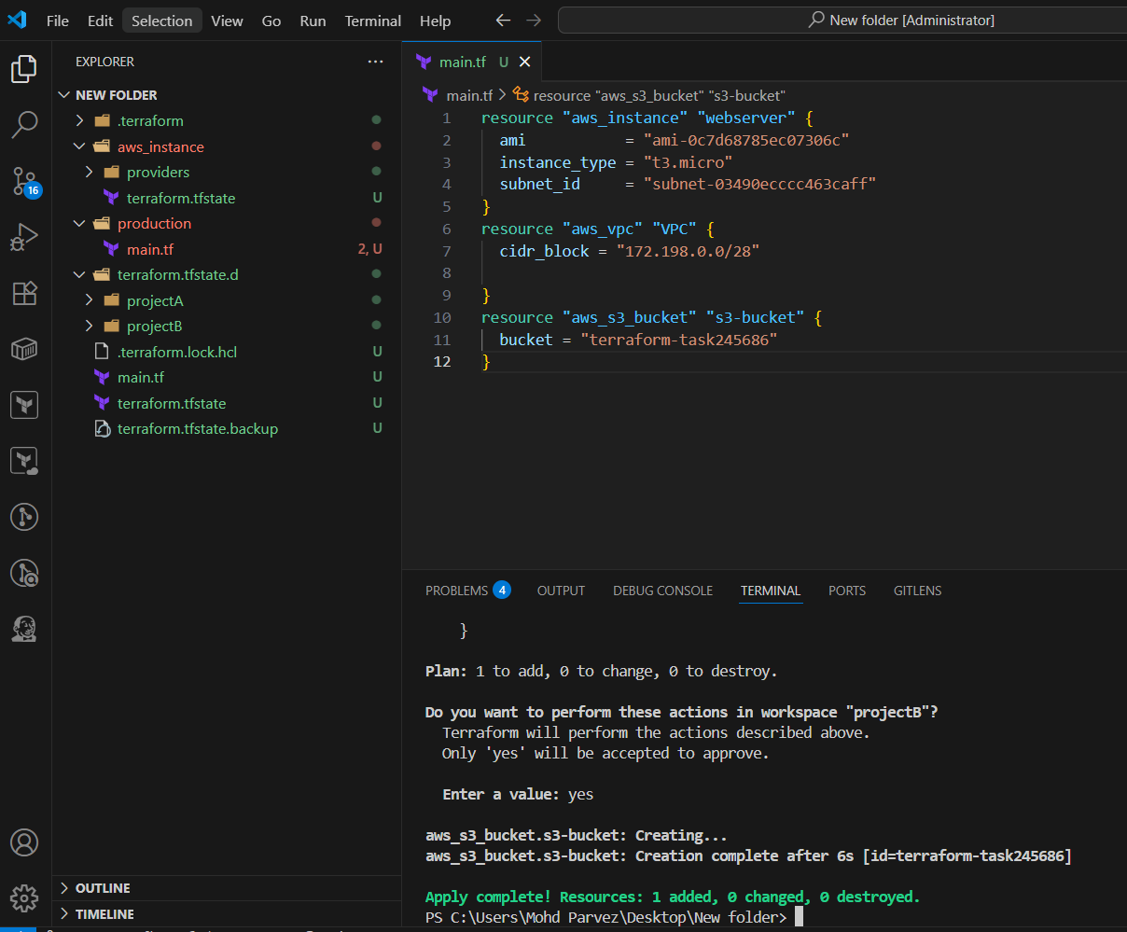
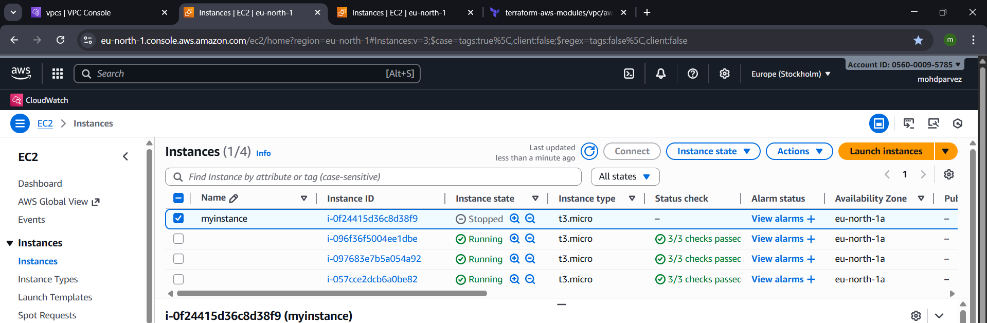
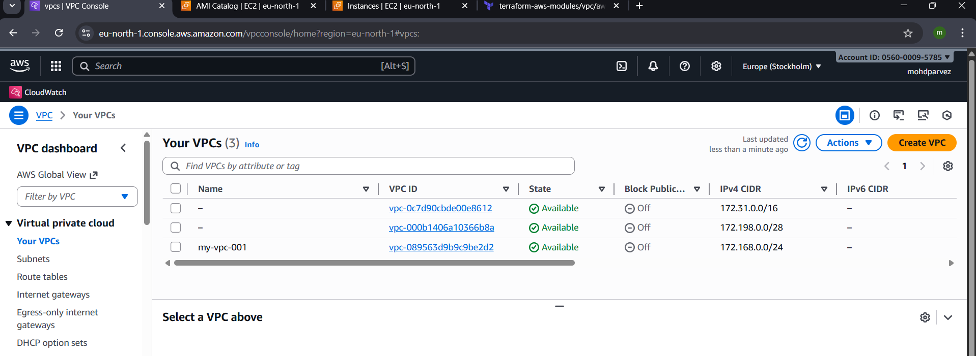
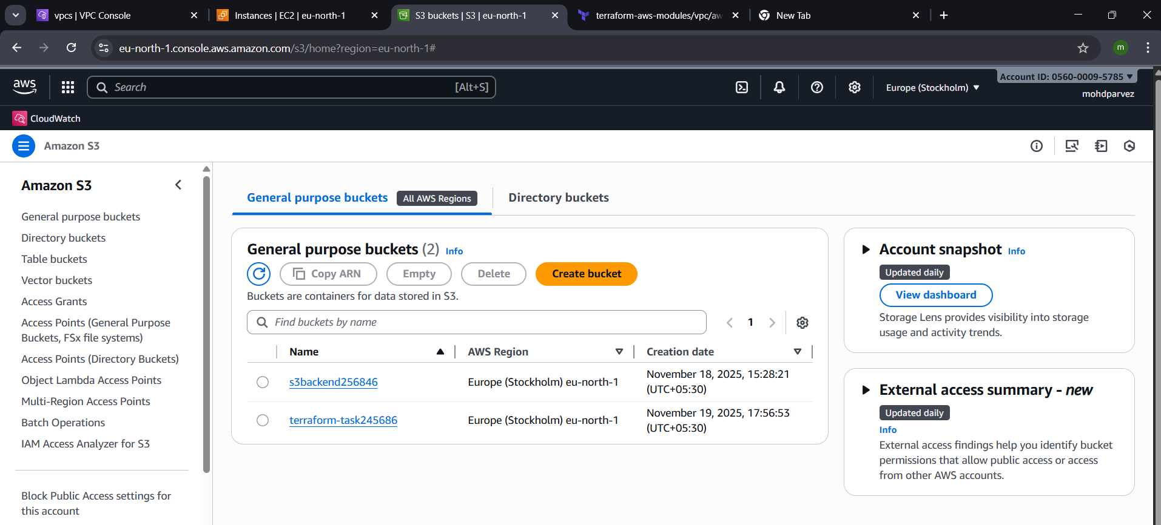

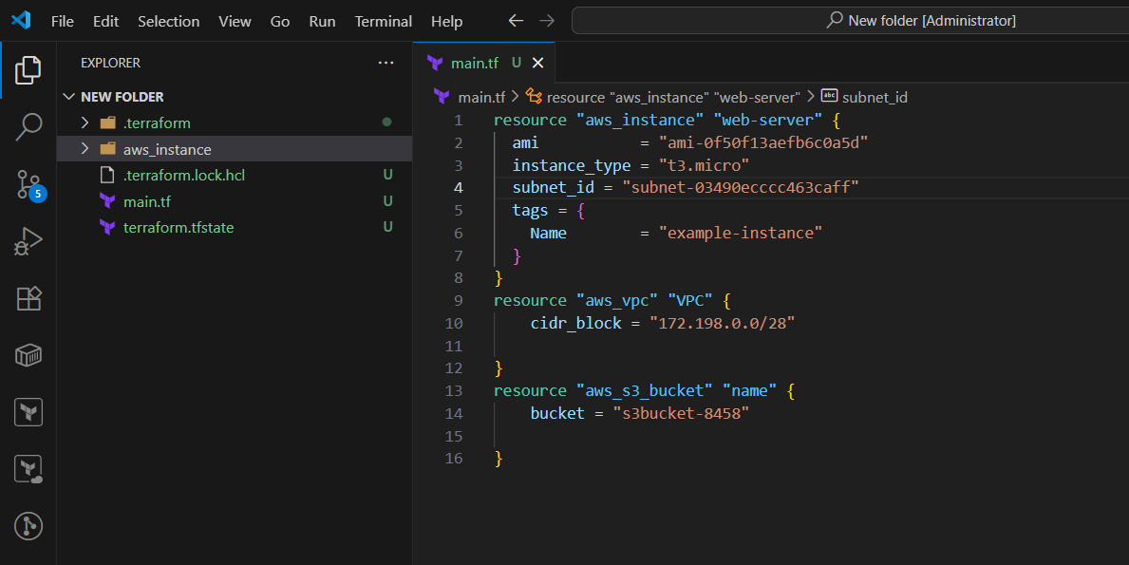
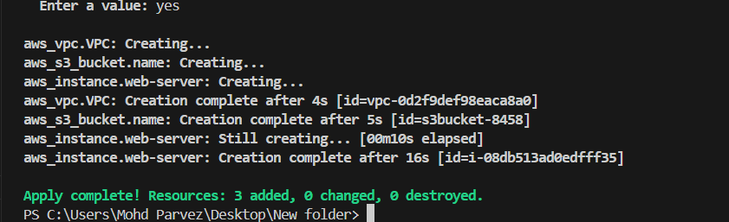
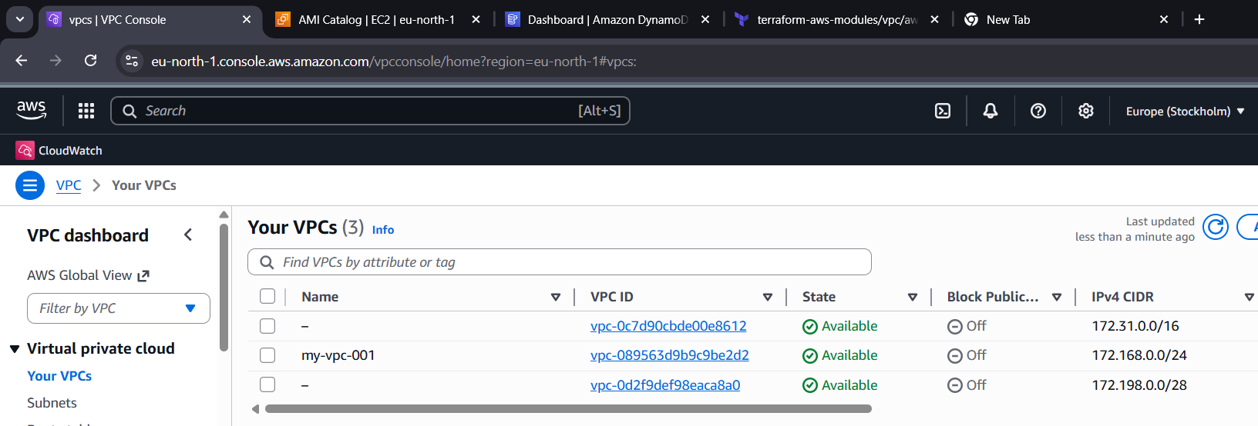
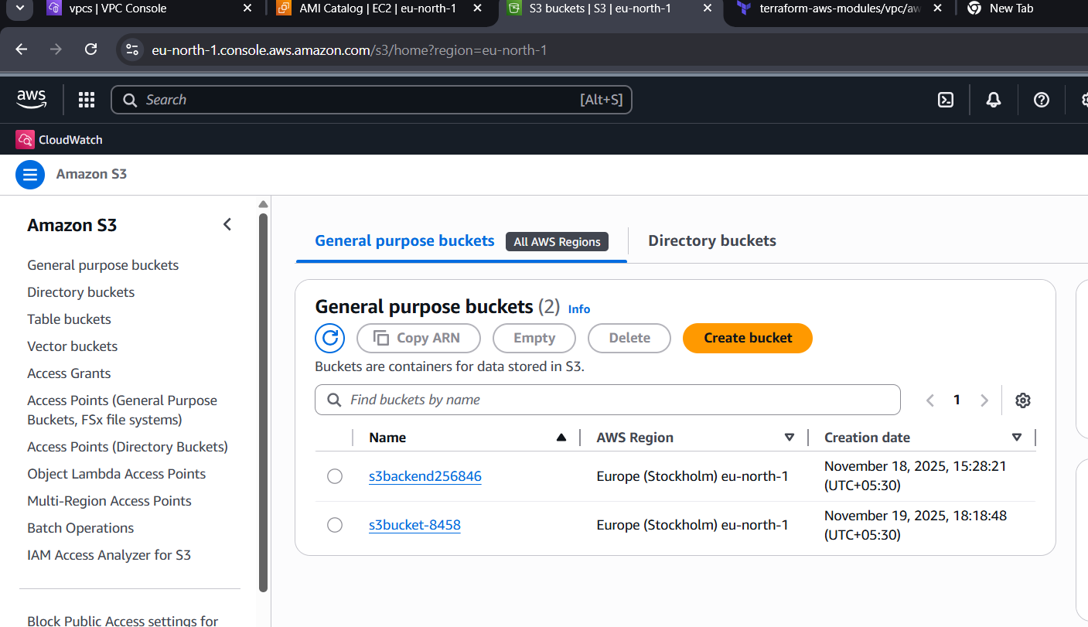
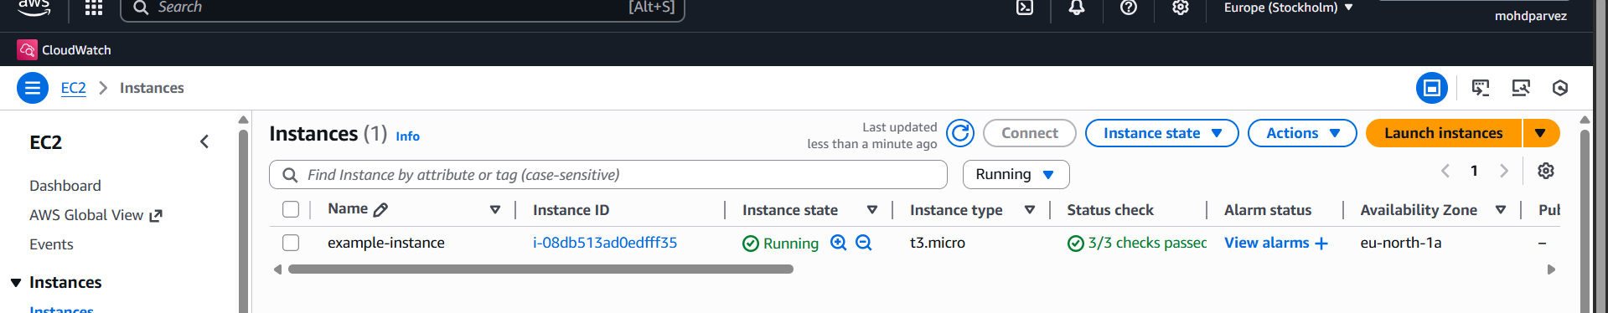

Provision EC2 for 3 different environments (Dev, Staging, and Prod) using Terraform workspaces.

to create the work spaces : terraform workspace new <name>
to list : terraform workspace list
